Botnet C2 traffic detection using deep learning
Abstract
Botnets remain one of the most dangerous threats in modern networks because they use covert command-and-control (C2) channels to coordinate large numbers of infected hosts while blending into normal traffic. These channels frequently operate over common protocols and ports such as HTTP, HTTPS, and DNS, and their payloads are increasingly encrypted, making traditional signature-based intrusion detection and payload inspection ineffective. At the same time, detailed flow-level datasets like CTU-13 and IoT-23 show that C2 traffic exhibits subtle but consistent patterns in packet timing, packet size distributions, flow duration, and directionality that can be exploited for detection.
This project proposes a deep learning–based botnet C2 detection system that operates on flow records rather than raw packets. Each flow is transformed into a fixed-length sequence capturing packet sizes, inter-arrival times, direction flags, and aggregate statistics, derived from labeled datasets that distinguish between benign traffic and malicious behaviors such as Attack, C&C, HeartBeat, DDoS, FileDownload, Mirai, Okiru, Torii, and PartOfAHorizontalPortScan. One-dimensional convolutional neural networks (1D CNNs) and recurrent architectures such as LSTM or GRU are trained to learn temporal and spatial patterns that differentiate C2 flows from normal connections, even when payloads are encrypted. Public botnet datasets including CTU-13, IoT-23, ISCX Botnet, and CIC-IDS are used to build and evaluate the models, ensuring coverage of multiple protocols, malware families, and network contexts.
The implemented system comprises data loading and preprocessing modules, a feature and sequence builder, deep-learning models for C2 versus benign classification, and a prediction and alerting module that flags suspicious flows for security operations center (SOC) teams. A Streamlit-based dashboard visualizes dataset statistics, model performance, and real-time predictions, providing analysts with an interpretable view of detected C2 activity. By focusing on flow-level sequence features and modern deep-learning architectures, the proposed system aims to reduce false negatives for stealthy botnets and enable earlier disruption of C2 infrastructures before large-scale attacks such as DDoS or data exfiltration can be launched.

Chapter 1: Introduction
1.1 Background
Botnets are large networks of compromised devices that are remotely controlled by an attacker through command-and-control (C2) infrastructure. These devices can be traditional PCs, servers, or increasingly, Internet of Things (IoT) devices such as cameras, routers, and smart home appliances. Once infected, each device periodically communicates with a C2 server or peer-to-peer overlay to receive instructions, download additional payloads, and participate in coordinated attacks such as distributed denial of service (DDoS), credential theft, or lateral movement inside a network.
Modern C2 channels are designed to be stealthy and resilient. Instead of using clearly malicious custom protocols, many botnets tunnel their C2 traffic over common protocols like HTTP, HTTPS, and DNS or use encrypted channels that are indistinguishable at the payload level from legitimate web and name-resolution traffic. Large public datasets such as CTU-13 and IoT-23 demonstrate that while payloads may be encrypted or obfuscated, C2 flows still exhibit characteristic patterns in packet timing, packet sizes, flow duration, and directionality that differ from benign flows. These subtle patterns form the basis for flow-based detection techniques that analyze metadata rather than raw payload content.
1.2 Problem Context
Traditional intrusion detection systems (IDS) and firewalls rely heavily on signatures, rule sets, and simple threshold-based anomaly detection. Signature-based IDS engines such as Snort and Suricata match packet payloads or header combinations against databases of known attack patterns. While highly effective for previously seen threats, these systems fail to detect new botnet families, polymorphic malware, or zero-day exploits whose signatures are not yet known. Even when signatures exist, encrypted C2 channels render payload inspection ineffective because the IDS cannot see beyond the TLS or application-level encryption.
Statistical anomaly-based systems monitor aggregate features like connection counts, byte volumes, and port usage per host to flag deviations from normal behavior. These systems can detect volumetric DDoS attacks or large-scale port scans but often struggle with “low-and-slow” C2 traffic that maintains a low profile by sending very few packets at irregular intervals. As botnets adopt techniques such as domain generation algorithms, fast-flux infrastructures, and multi-stage infection chains, static rules and fixed thresholds become increasingly brittle. The result is a gap between the sophistication of modern botnets and the capabilities of many operational detection tools, especially with respect to early-stage C2 detection.
1.3 Motivation
Early detection of C2 traffic is critical because it allows defenders to disrupt an attack at an early point in the kill chain, before large-scale damage occurs. If an organization can reliably identify flows that correspond to C2 beacons, heartbeats, or tasking messages, it can isolate compromised hosts, block communication to malicious command servers, and prevent subsequent stages such as data exfiltration or DDoS participation. Flow-level datasets like CTU-13 and IoT-23 show that even when payloads are encrypted or partially obfuscated, malicious sessions often differ from benign traffic in measurable ways, including periodicity, average packet size, ratio of inbound to outbound bytes, and the distribution of inter-arrival times.
Recent research indicates that deep learning models, particularly one-dimensional convolutional neural networks (1D CNNs) and recurrent architectures such as LSTM and GRU, can learn these patterns directly from sequences of flow-level features. Unlike classical machine-learning models that require hand-crafted aggregate features, deep networks can operate on ordered sequences of per-packet or per-time-bin statistics, capturing both spatial patterns (e.g., repeated size motifs) and temporal dependencies (e.g., regular heartbeats). This capability makes them promising candidates for robust C2 detection across diverse protocols and botnet families.
1.4 Project Aim and Objectives
The overarching aim of this project is to design and implement a flow-based deep learning system that detects botnet C2 traffic using only network-level metadata and sequence patterns. Building on public datasets and the label semantics defined by Stratosphere Labs and related efforts, the system focuses on differentiating benign traffic from malicious behaviors such as C&C, HeartBeat, DDoS, Attack, FileDownload, and known IoT botnet families like Mirai, Okiru, and Torii.
Specific objectives are:
- To construct a labeled dataset of flows that combines benign and malicious traffic from CTU-13, IoT-23, CIC-IDS, and related corpora, focusing on C2-relevant labels and ensuring a balanced representation of classes.
- To design a preprocessing pipeline that:
  - Cleans and normalizes flow records.
  - Extracts per-packet or per-time-bin features such as packet sizes, inter-arrival times, and direction flags.
  - Aggregates flow-level statistics such as duration, total bytes, and number of packets.
  - Converts each flow into a fixed-length sequence suitable for deep-learning models.
- To implement and compare deep-learning architectures, specifically:
  - A 1D CNN that focuses on local patterns in sequences.
  - An LSTM or GRU network that emphasizes temporal dependencies and long-range correlations.
  - Optionally, a hybrid CNN-LSTM model that combines both capabilities, as suggested in recent IoT botnet detection studies.
- To evaluate the models using standard metrics (accuracy, precision, recall, F1-score, confusion matrix) with a particular emphasis on minimizing false negatives for C2 and related labels.
- To integrate the trained model into a prototype detection pipeline that exposes a prediction and alerting module and a Streamlit dashboard that visualizes flow statistics, model outputs, and alerts for SOC analysts.
1.5 Dataset and Label Semantics
The project uses flow-level data and labels inspired by CTU-13, IoT-23, and similar datasets curated by Stratosphere Labs and academic collaborators. These datasets label each flow with a category derived from manual or semi-automated analysis of payloads, timing, and external threat intelligence. Relevant labels include:
- Benign: Connections where no suspicious or malicious activity has been detected. These flows form the baseline of normal traffic.
- Attack: Flows from infected devices that attempt to exploit vulnerable services, such as brute-force logins or injection attacks, typically identified through payload patterns and behavioral analysis.
- C&C (Command and Control): Flows in which an infected device connects to a command server to fetch commands, exfiltrate data, or download binaries. These flows usually show periodic behavior or characteristic response sizes associated with botnet tasking.
- DDoS: High-volume flows that contribute to a distributed denial-of-service attack, often recognized by many flows toward a single IP address over a short time window.
- FileDownload: Flows where substantial response payloads indicate that malware binaries or tools are being downloaded to an infected host, often to known malicious IPs or ports.
- HeartBeat: Very small, periodic flows that allow the C2 server to monitor the status and availability of infected hosts, typically exhibiting minimal response sizes and high regularity.
- Mirai, Okiru, Torii: Family-specific labels assigned when a flow’s behavior matches known patterns of these IoT botnets, such as characteristic scan sequences, C2 domains, or exploit payloads.
- PartOfAHorizontalPortScan: Flows that are part of a horizontal port scan across multiple targets, sharing similar ports and byte counts and occurring in coordinated bursts.
For this project, these labels can be used in two ways:
- As a binary problem, where all malicious labels (e.g., C&C, HeartBeat, DDoS, Attack, FileDownload, Mirai, Okiru, Torii, PartOfAHorizontalPortScan) are grouped into a single “Malicious/C2-related” class against “Benign”.
- As a multi-class problem, where separate models or output heads predict more detailed categories, enabling richer threat characterization for analysts.
1.6 Deep Learning Approach
The core idea is to represent each flow as a sequence of feature vectors over time, where each element corresponds to a packet or a small time bin. Features per element may include:
- Packet size (bytes).
- Inter-arrival time relative to the previous packet.
- Direction flag (e.g., client-to-server vs server-to-client).
- Cumulative bytes or packet counts up to that point.
Since flows differ in length, sequences are padded or truncated to a fixed length, and numeric features are scaled using Z-score or MinMax normalization to stabilize training. A 1D CNN model slides convolutional filters across this sequence to detect local patterns and motifs associated with specific behaviors, such as regular bursts or characteristic size sequences. An LSTM or GRU model ingests the sequence to capture temporal dependencies, such as the periodicity of heartbeats or the timing between attack bursts.
By training on labeled flows from CTU-13, IoT-23, and related datasets, the models learn to map sequences to probabilities over classes. During inference, the trained model processes new flow sequences and outputs a probability that the flow belongs to the C2 or malicious class, which is then thresholded to generate alerts.
1.7 System Overview
At a high level, the proposed system comprises the following modules:
- Data Loading Module: Imports flow records from CSV or similar formats derived from CTU-13, IoT-23, CIC-IDS, and ISCX datasets.
- Preprocessing Module: Cleans missing or inconsistent fields, normalizes numeric attributes, and transforms flows into fixed-length sequences of feature vectors.
- Feature & Sequence Builder: Extracts packet-level and flow-level features, constructs per-flow sequences, and stores them as arrays ready for model training and inference.
- Deep Learning Module: Defines, trains, and saves the 1D CNN and LSTM/GRU models for C2 vs benign classification, optionally supporting multi-class outputs.
- Prediction & Alert Module: Accepts new flow data, applies the same preprocessing and feature extraction, runs inference, and generates alert records when probabilities exceed configured thresholds.
- Dashboard Module: Implements a Streamlit front-end that displays dataset statistics, current model performance, and real-time classification results and alerts for SOC analysts.

Chapter 2: Literature Survey
2.1 Overview of Botnet and C2 Detection Research
Research on botnet detection has evolved from simple signature matching to sophisticated machine learning and deep learning models that reason over large volumes of network traffic. Early work focused on identifying clearly malicious payload patterns, known command strings, or fixed communication endpoints. As attackers shifted toward encrypted and covert command-and-control (C2) channels, the research community began to emphasize behavioral characteristics that remain observable even when payload content is hidden. These characteristics include packet timing, flow duration, packet size distributions, protocol usage, and the spatial–temporal correlation of flows across multiple hosts.
Within this broader context, flow-based botnet detection has emerged as a prominent direction. Instead of inspecting individual packets, flow-based approaches aggregate traffic into bi-directional or uni-directional flows characterized by features such as source and destination addresses, ports, protocol, byte counts, packet counts, and timestamps. Flow-level analysis scales better to high-volume environments and aligns naturally with how many network devices export telemetry (for example, NetFlow and IPFIX). However, summarizing packets into flows also removes some fine-grained information, motivating the use of advanced models capable of extracting as much signal as possible from the remaining metadata.
2.2 Classical Intrusion Detection and Signature-Based Systems
Signature-based intrusion detection systems (IDS) like Snort and Suricata historically formed the first line of defense against network threats. These systems maintain rule sets describing known attack fingerprints, including specific byte patterns, request sequences, or protocol anomalies. When incoming traffic matches a rule, the IDS generates an alert. This approach is highly precise for previously seen attacks and can be updated rapidly when new signatures are contributed by security vendors.
However, signature-based approaches have significant limitations when dealing with modern botnets and C2 channels. Encrypted traffic obscures payload content, rendering payload-level signatures ineffective. Even unencrypted C2 protocols can be modified or randomized to evade static signatures. Attackers can also employ domain generation algorithms and fast-flux infrastructures, rotating hostnames and IP addresses faster than signature lists can be updated. As a result, signature-based systems are often reactive and struggle to detect zero-day malware or families that do not closely resemble known patterns.
2.3 Anomaly-Based and Statistical Detection
To address the inflexibility of signatures, anomaly-based intrusion detection models were proposed. These methods build a baseline model of “normal” network behavior and then flag deviations from that baseline as potential intrusions. Typical anomaly-based features include connection counts, bandwidth usage, port distributions, and session durations. Techniques range from simple thresholding and statistical hypothesis tests to clustering and density estimation.
Anomaly-based detection is attractive because it can, in principle, catch previously unseen threats. However, in practice it faces substantial challenges. Normal traffic patterns can be highly variable, especially in large, heterogeneous networks. This variability leads to high false positive rates, where unusual but legitimate behavior is flagged as malicious. To maintain operational usability, thresholds must be tuned carefully, which can reintroduce blind spots where stealthy C2 traffic hides within acceptable bounds. Furthermore, many statistical methods operate on aggregate features over long time windows, making them less sensitive to the fine-structured timing and sequence patterns that characterize C2 heartbeats or command exchanges.
2.4 Flow-Based Botnet Detection
Flow-based analysis represents a middle ground between packet-level inspection and coarse traffic statistics. A flow is typically defined as a unidirectional or bidirectional sequence of packets sharing common 5-tuple attributes (source IP, destination IP, source port, destination port, protocol) within a given timeout. For each flow, features such as total bytes, total packets, average packet size, and flow duration can be computed. Additional indicators may include TCP flags, the ratio of inbound to outbound traffic, and measures of burstiness or periodicity.
Several flow-based botnet detection systems have been proposed. Some rely on clustering to group hosts with similar connection patterns and then identify clusters that exhibit botnet-like behavior. Others analyze flows in two planes: a communication-plane that considers similarity in connectivity patterns (for example, common C2 servers) and an activity-plane that considers similarity in malicious behaviors (for example, shared attack targets or ports). These approaches highlight the importance of correlating flows across time and hosts, but many originally used relatively simple statistics or clustering algorithms that do not fully exploit the sequential structure within flows.
Recent works extend flow-based detection by incorporating time-series features and using more expressive models. For instance, research on encrypted traffic analysis shows that even when payloads are hidden, sequence-level features such as packet lengths and inter-arrival times can distinguish between different application types and malware families. This insight underpins the move toward sequence modeling, where each flow is represented as an ordered series of feature vectors rather than a static summary.
2.5 Public Datasets for Botnet Research
The development and evaluation of botnet detection systems depend heavily on representative, labeled datasets. Several widely used corpora have shaped the research landscape.
The CTU-13 dataset contains traffic from thirteen different botnet scenarios mixed with normal and background traffic. Each scenario corresponds to a specific malware sample, and flows are labeled as Background, Botnet, C&C Channels, or Normal. This dataset is noteworthy for its real network conditions and for the manual labeling of flows in the NetFlow representation. Researchers have used CTU-13 to study differences in protocol usage, packet size distributions, and temporal behavior between benign and botnet traffic, as well as to benchmark machine-learning detectors.
The IoT-23 dataset focuses on malicious and benign IoT traffic. It includes multiple scenarios with different malware families, such as Mirai, Okiru, and Torii, and benign captures from non-infected IoT devices. Labels are assigned at the flow level to categories like Benign, Attack, C&C, HeartBeat, FileDownload, DDoS, and PartOfAHorizontalPortScan. These labels were created through careful manual analysis that combines payload inspection, behavioral patterns, and knowledge of known malicious IPs and domains. IoT-23 has become a reference dataset for research on IoT botnet detection, especially for family-specific and behavior-specific classification.
Other relevant datasets include ISCX Botnet, which provides flow-level records with rich feature sets for machine learning, and CIC-IDS 2017/2018, which contain multiple types of attacks including DDoS, brute force, and botnet-like flows. Together, these datasets support both binary (benign vs malicious) and multi-class classification tasks, and they cover a range of protocols and network environments.
2.6 Machine Learning for Network Intrusion and Botnet Detection
With the availability of these datasets, classical machine learning techniques have been widely applied to intrusion and botnet detection. Common algorithms include decision trees, random forests, support vector machines (SVM), k-nearest neighbors, and ensemble methods. These models typically operate on feature vectors derived from flows or aggregated statistics.
Numerous studies report promising detection accuracies using such methods, often outperforming basic threshold-based anomaly detectors. However, classical machine learning models rely heavily on manual feature engineering. Features are often hand-crafted aggregates such as average packet size, standard deviation of inter-arrival times, or counts of different TCP flags. While these features capture some aspects of behavior, they may discard important temporal ordering information. Additionally, many models treat each flow as an independent sample, ignoring correlations across time and between flows belonging to the same host or attack campaign.
Another challenge is that classical models can struggle with complex, high-dimensional feature spaces common in network telemetry. Feature selection and dimensionality reduction techniques such as principal component analysis (PCA) are often required to manage computational costs and avoid overfitting. These preprocessing steps add complexity and may lose subtle patterns needed for accurate C2 detection.
2.7 Deep Learning for Network and IoT Botnet Detection
Deep learning has been increasingly explored for network intrusion and botnet detection because of its ability to learn hierarchical representations directly from raw or minimally processed data. In the context of network security, common architectures include fully connected neural networks, convolutional neural networks (CNN), recurrent neural networks (RNN) such as LSTM and GRU, and hybrid combinations like CNN-LSTM.
One line of research applies CNNs to fixed-length feature vectors derived from flows. Convolutional layers can capture local patterns in the feature space, reducing the need for extensive feature engineering. Another line represents packet sequences or flow sequences as one-dimensional time series, using 1D CNNs to detect local motifs and LSTM/GRU layers to model long-range temporal dependencies. Studies on IoT botnet detection have shown that hybrid CNN-LSTM models can achieve high detection accuracy on datasets containing malware such as Mirai and BASHLITE, often outperforming traditional machine-learning baselines.
Deep autoencoders and variational autoencoders have also been used for unsupervised anomaly detection, learning compact representations of normal traffic and identifying flows that deviate significantly from this learned manifold. While promising, purely unsupervised approaches can produce many false positives if normal traffic is highly diverse. For C2 detection, supervised or semi-supervised deep models that leverage labeled flows tend to provide more precise discrimination between benign and malicious behaviors.
2.8 Flow-Level Deep Learning for C2 Detection
Specifically targeting C2 detection, several works adopt flow-level deep learning models. These models typically:
- Represent each flow as a sequence of packet sizes, inter-arrival times, and direction flags.
- Normalize and pad/truncate sequences to a fixed length.
- Feed sequences into 1D CNNs, LSTMs, or hybrid CNN-LSTM architectures.
Research on early detection of IoT botnets highlights that packet-based methods can detect C2 traffic with very high success rates, while flow-based methods, though slightly less precise, still achieve strong performance with lower data volume and better scalability. Such studies also confirm that heartbeat-style traffic, with very small and regular packets, is harder to detect than high-volume scan or download traffic, emphasizing the need for models that are sensitive to subtle temporal structures rather than just aggregate statistics.
Other work combines flow-level features with graph-based or topological information, such as communication patterns between hosts, to build richer models of botnet behavior. Deeply fused approaches use separate branches for flow features and network topology, merging them in later layers to improve detection performance. These methods underscore that C2 behavior has both local (per-flow) and global (network-wide) dimensions.
2.9 Labeled Behavior Semantics and Explainability
A distinguishing characteristic of datasets such as IoT-23 is the use of detailed behavior-oriented labels (C&C, HeartBeat, FileDownload, DDoS, PartOfAHorizontalPortScan, and family-specific tags) created through manual analysis by experts. This labeling allows models not only to detect anomalies but also to classify the type of malicious activity, which is highly valuable for incident response. For example, distinguishing between C&C flows and DDoS flows helps prioritize remediation actions and understand the stage of the attack lifecycle.
Explainability remains a challenge for deep learning models in security contexts. Analysts often require human-interpretable explanations of why a flow was flagged as malicious. While most literature focuses on improving raw detection metrics, there is a growing interest in techniques such as saliency maps and attention mechanisms that highlight which parts of a sequence contributed most to a classification decision. Combined with semantically rich labels, these techniques can offer more transparent insights into how a model distinguishes C2 traffic from benign connections.
2.10 Identified Research Gaps
The literature reveals several gaps and opportunities that motivate the present project:
- Many commercial and open-source tools still predominantly rely on signatures, static rules, or coarse anomaly detectors, despite research demonstrating the benefits of deep learning for sequence-level flow analysis. There is a need for practical, implementable pipelines that bridge this gap and can be integrated into existing security operations workflows.
- A large proportion of academic work treats intrusion detection as a generic binary classification problem (benign vs malicious) and does not fully leverage the rich label taxonomies available in modern datasets. As a result, detection models may not capture distinctions between different malicious behaviors, particularly those directly associated with C2 channels such as HeartBeat and FileDownload.
- While several studies have explored packet-based detection, fewer focus on flow-based deep learning approaches that work with summarized telemetry commonly available in real networks. Flow-based methods are attractive because they require less storage and processing than full packet captures, but they demand careful feature design and sequence modeling to compensate for the loss of raw payload information.
- Many research prototypes demonstrate high accuracy under controlled conditions but provide limited detail on end-to-end system design, including data ingestion, preprocessing pipelines, model deployment, alerting mechanisms, and analyst-facing dashboards. This limits their direct applicability in operational environments such as security operations centers.
- Evaluation methodologies sometimes overlook key practical metrics such as false negative rates specifically for C2 flows, detection latency, and robustness to imbalanced datasets where benign traffic vastly outnumbers malicious flows.
2.11 Positioning of the Proposed Work
The proposed project positions itself at the intersection of flow-based analysis, deep sequence modeling, and behavior-oriented labeling. By using labeled flows from datasets that distinguish Attack, C&C, HeartBeat, DDoS, FileDownload, Mirai, Okiru, Torii, and related categories, the system can explicitly target the detection of C2-style behaviors rather than treating all malicious traffic as a single class. The use of 1D CNN and LSTM/GRU architectures over fixed-length sequences of packet-level features allows the model to exploit both local patterns and temporal dependencies within flows.
Furthermore, the project emphasizes an end-to-end implementation that includes data loading, preprocessing, feature and sequence building, model training, prediction and alert generation, and a Streamlit-based dashboard. This comprehensive design addresses the practical deployment gaps identified in the literature and aims to produce not only a theoretical model but a prototype that reflects the constraints and needs of real-world security monitoring environments. Subsequent chapters build on this literature foundation to analyze system requirements, justify design decisions, and describe the architecture and implementation in detail.

Chapter 3: System Analysis
3.1 Problem Definition
The central problem addressed in this project is the reliable detection of botnet command-and-control (C2) traffic using flow-level network data and deep learning. Botnets increasingly use covert C2 channels that are encrypted, low-volume, and protocol-agnostic, making them difficult to distinguish from benign traffic with traditional tools. The system must identify flows that correspond to behaviors such as C&C, HeartBeat, DDoS coordination, FileDownload of malware, and multi-family activity (for example, Mirai, Okiru, Torii), using only observable metadata such as packet timing, packet sizes, directions, and aggregate flow statistics.
From a system-analysis perspective, this problem entails several intertwined challenges:
- The need to operate on flow-level or packet-sequence data that may be high-dimensional and heterogeneous.
- The presence of multiple behavior labels (Benign, Attack, C&C, HeartBeat, DDoS, FileDownload, Mirai-family, Okiru-family, Torii-family, PartOfAHorizontalPortScan) that may be heavily imbalanced.
- The requirement to generalize across different datasets and network environments without overfitting to any single capture scenario.
- The necessity to deliver outputs in a form that is actionable for security operations center (SOC) teams, including clear alerts and basic interpretability.
The analysis in this chapter formalizes functional and non-functional requirements, examines the limitations of existing approaches, and provides justification for each major design decision made for the proposed system.
3.2 Functional Requirements
The system must satisfy the following core functional requirements. These are organized by logical modules that will later map to implementation components.
3.2.1 Data Ingestion and Management
- Ability to load flow-level data from multiple public botnet datasets in CSV or similar tabular formats.
- Support for combining benign and malicious samples from different sources (for example, CTU-13, IoT-23, CIC-IDS, ISCX) into a unified training and evaluation corpus.
- Handling of label semantics that distinguish:
  - Benign vs malicious flows.
  - Specific malicious behaviors (Attack, C&C, HeartBeat, DDoS, FileDownload, PartOfAHorizontalPortScan).
  - Malware-family labels (Mirai, Okiru, Torii) where available.
- Facilities for splitting data into training, validation, and test sets in a reproducible way, preserving realistic class distributions.
3.2.2 Preprocessing and Feature Engineering
- Cleaning of missing, inconsistent, or out-of-range values in the raw flow records.
- Normalization or scaling of numeric attributes (for example, Z-score or MinMax scaling) to stabilize deep-learning training.
- Conversion of flows into structured feature representations, including:
  - Packet-level sequences of sizes, inter-arrival times, and directions.
  - Flow-level summary features such as duration, total bytes, packet counts, and byte ratios.
- Construction of fixed-length sequences for each flow by padding or truncating to a configurable length (for example, 100 time steps).
- Efficient storage of processed features (for example, NumPy arrays) for repeated training experiments.
3.2.3 Model Training and Selection
- Implementation of one or more deep-learning architectures suited to sequence data, specifically:
  - A 1D convolutional neural network (CNN) for learning local temporal patterns.
  - A recurrent neural network (RNN) variant such as LSTM or GRU for modeling long-range dependencies.
  - Optionally, a hybrid CNN-LSTM configuration stacking convolutional layers in front of recurrent layers.
- Configuration of training hyperparameters (learning rate, batch size, number of epochs, optimizer choice, dropout rates, regularization).
- Support for binary classification (Benign vs C2-related) and, where feasible, multi-class classification across behavior labels.
- Mechanisms for early stopping, checkpointing, and model selection based on validation metrics.
3.2.4 Inference and Alerting
- A prediction interface (for example, a function, REST API, or module) that:
  - Accepts raw flow records or sequences.
  - Applies the same preprocessing and feature construction as used during training.
  - Produces class probabilities and predicted labels.
- Threshold-based alerting logic that:
  - Flags flows as C2 or malicious when the predicted probability exceeds configurable thresholds.
  - Associates alerts with metadata including timestamps, source and destination addresses, label type, and model confidence.
- Logging of alerts and predictions to a persistent store for subsequent analysis and auditing.
3.2.5 Visualization and Analyst Interaction
- A dashboard interface (for example, built with Streamlit) that provides:
  - Dataset statistics (class distributions, basic feature histograms).
  - Model performance summaries (metrics, confusion matrices).
  - Real-time or batch prediction views, listing flows and their predicted labels.
  - An alert view showing C2-related detections with filters by label type and time.
- Simple interpretability cues, such as indicating whether a detection was driven primarily by periodic heartbeats, unusual size patterns, or high flow volumes.
3.3 Non-Functional Requirements
In addition to core functionality, the system must meet several non-functional requirements that affect usability, maintainability, and deployment.
3.3.1 Performance and Latency
- Training time must be reasonable on commodity hardware (for example, a workstation with an Intel i5 or similar processor, 8–16 GB RAM, and optional GPU).
- Inference latency for a single flow should be low enough to support near-real-time or batch-near-real-time analysis.
- Preprocessing and sequence construction should be vectorized where possible to avoid bottlenecks on large datasets.
3.3.2 Scalability
- The architecture should scale from small lab datasets to larger enterprise-sized corpora by:
  - Allowing incremental training or fine-tuning as new labeled data becomes available.
  - Supporting batched inference on large sets of flows.
  - Being amenable to horizontal scaling (for example, running multiple inference workers).
3.3.3 Robustness and Reliability
- The system must handle incomplete or noisy data gracefully, defaulting to safe behavior (for example, treating unprocessable flows as unknown rather than benign).
- Logging and error handling should capture failures in data ingestion, preprocessing, or inference without crashing the entire pipeline.
- Model files, configuration, and processed data should be versioned and backed up.

3.3.4 Security and Privacy
- Only flow metadata is processed; payload content is not required, reducing privacy concerns.
- Access to the model, predictions, and logs should be controlled via appropriate authentication when integrated into real environments.
- Sensitive identifiers (for example, specific IPs) can be pseudonymized or anonymized where required by policy.
3.3.5 Maintainability and Extensibility
- The codebase should be modular, with clear separation between data loading, preprocessing, modeling, inference, and UI.
- Configuration files (for example, YAML or JSON) should define dataset paths, feature selections, and hyperparameters to avoid hard-coding.
- It should be straightforward to plug in:
  - New datasets.
  - New feature extraction schemes.
  - Alternative models (for example, transformers, graph neural networks) in future work.
3.4 Analysis of Existing Approaches
To justify design choices, it is important to analyze why existing families of solutions are insufficient for this project’s objectives.
3.4.1 Signature-Based and Rule-Based Systems
Signature-based IDS can detect known botnet traffic as long as the C2 protocol and indicators are stable and publicly documented. However, modern botnets:
- Encrypt their C2 payloads, making traditional content signatures ineffective.
- Frequently change domains and IP addresses, invalidating static indicators.
- Use legitimate protocols and ports (for example, HTTPS on port 443), blending into normal traffic.
Rule-based systems that rely on simple heuristics (for example, “block all traffic to a certain port” or “flag more than N connections per second”) may catch obvious anomalies but perform poorly against low-and-slow C2 channels that intentionally mimic human or application patterns. These properties make purely signature- or rule-centric approaches insufficient for robust C2 detection.
3.4.2 Statistical and Classical Machine Learning
Statistical anomaly detectors and classical machine-learning models (for example, random forests, SVM) improve on static rules by modeling traffic in a higher-dimensional feature space. They can detect some previously unseen threats through deviations from learned baselines. However, they often assume independence between samples and work on aggregated features that obscure temporal structure. For C2 flows that rely on periodic heartbeats or irregular but characteristic timing, the ordering of packets can be as informative as their aggregate statistics.
Moreover, classical models may struggle with:
- High class imbalance, where benign flows greatly outnumber malicious ones.
- The need to capture subtle differences between benign periodic traffic (for example, health checks) and malicious heartbeats.
- Complex multi-label semantics where flows can belong to different behavior categories.
These limitations motivate the use of deep sequence models that can directly ingest ordered per-packet or per-time-bin features.
3.5 Constraints and Challenges
A thorough system analysis must account for practical constraints that shape design choices.
3.5.1 Data Quality and Heterogeneity
Public botnet datasets differ in capture environment, feature sets, and label conventions. For example:
- One dataset may include detailed TCP flags and precise timestamps, while another may only report aggregated flow statistics.
- Label taxonomies may use slightly different names for similar behaviors or merge some categories.
- There may be noise in labels, especially in large captures where manual annotation is challenging.
The system must therefore include a normalization layer that reconciles differences between datasets and selects a common subset of features and labels for modeling. It must also be tolerant of noisy labels and missing values.
3.5.2 Class Imbalance
In realistic network traffic, benign flows dominate. Even in curated datasets, malicious flows are often fewer than benign ones. Within malicious categories, some behaviors or families (for example, HeartBeat or Torii) may be far rarer than others (for example, generic Attack or DDoS). Severe imbalance can cause models to:
- Favor majority classes, leading to many false negatives for rare C2 behaviors.
- Overfit to specific frequent patterns while ignoring subtle indicators.
Addressing class imbalance requires techniques such as:
- Stratified sampling or class-balanced mini-batches.
- Class weighting or focal losses.
- Oversampling of minority classes or data augmentation at the feature level.
3.5.3 Resource Constraints
Deep-learning training can be computationally intensive. The design must consider that:
- Not all deployment environments will have GPUs; CPU-friendly architectures may be necessary.
- Sequence length and model depth must be chosen to balance detection quality against memory and time.
- Feature extraction should avoid excessive complexity; using only a handful of well-chosen per-packet features can dramatically reduce computational requirements compared to extracting many derived metrics.
3.5.4 Concept Drift
Network behavior and attack patterns change over time. A model trained on one set of captures may degrade when exposed to new C2 techniques or network configurations. The system needs to be:
- Retrainable with new labeled data as it becomes available.
- Potentially adaptive, using mechanisms such as periodic retraining, incremental learning, or monitoring of performance drift.
While full concept-drift management may be beyond the initial scope, the design must not preclude such extensions.
3.6 Justification of System Choices
Based on the above analysis, the key design decisions in the proposed system are justified as follows.
3.6.1 Flow-Level, Sequence-Based Modeling
The system operates on flow-level sequences of packet features rather than raw packet payloads. This choice is driven by:
- Practicality: Flow records are widely available from routers and probes; full packet captures are storage- and privacy-heavy.
- Privacy: Excluding payloads reduces exposure to sensitive content.
- Expressiveness: Packet-level sequences within a flow retain crucial temporal and size information needed to distinguish C2 patterns.
By constructing fixed-length sequences and feeding them to sequence models, the system exploits the ordering information that classical feature vectors often discard.
3.6.2 Use of 1D CNN and LSTM/GRU
1D CNNs efficiently capture local patterns such as repeated size motifs, bursts, or micro-structures in timing. LSTM/GRU networks are well suited to modeling long-range dependencies, such as periodic heartbeats or multi-stage handshake patterns. A hybrid CNN-LSTM architecture can exploit both strengths: convolutional layers provide local feature extraction, and recurrent layers interpret how these local patterns evolve over time.
This combination is supported by prior research that demonstrates strong performance of CNN-LSTM models on IoT botnet datasets, particularly for multi-class classification across different attack types. Using widely studied architectures also ensures that training behavior, hyperparameter tuning, and debugging are well understood.
3.6.3 Behavior-Oriented Labeling
Instead of collapsing all malicious flows into a single class, the system leverages behavior-oriented labels (Benign, Attack, C&C, HeartBeat, DDoS, FileDownload, PartOfAHorizontalPortScan, Mirai, Okiru, Torii) wherever possible. This has several benefits:
- It enables more targeted models (for example, focusing specifically on C&C vs Benign).
- It supports multi-task learning or multi-label extensions in future work, where the model predicts both maliciousness and behavior type.
- It provides richer information to SOC teams, who can prioritize remediation based on whether traffic is early-stage C2, active DDoS, or merely reconnaissance.
For the initial implementation, a binary classifier focusing on C2-related vs Benign flows may be constructed, while retaining the underlying labels for later expansion.
3.6.4 Modular Pipeline and Dashboard
The system is designed as a modular pipeline rather than a monolithic application. This modularity:
- Facilitates independent development and testing of data loading, preprocessing, modeling, and visualization components.
- Allows substitutions (for example, replacing the deep model or feature extractor) without rewriting the entire codebase.
- Aligns with deployment practices where data ingestion, detection engines, and dashboards are often separate services.
A dashboard is included to bridge the gap between model outputs and human operators. Even the most accurate detection model has limited value if its results are not presented in a clear, interpretable, and timely manner.
3.7 Summary
This chapter analyzed the problem of detecting botnet C2 traffic using flow-level data and deep learning, establishing the functional and non-functional requirements for the proposed system. It examined the limitations of existing signature-based, rule-based, and classical machine-learning approaches, and identified key constraints such as data heterogeneity, class imbalance, resource limits, and concept drift.
The analysis justified major design decisions: adopting flow-level sequence modeling, using 1D CNN and LSTM/GRU architectures, leveraging behavior-oriented labels, and implementing a modular, dashboard-connected pipeline. These decisions are grounded in both the technical challenges of C2 detection and the practical realities of deploying detection systems in operational environments. The next chapter builds upon this analysis to describe the detailed system design, including architecture, data flow, module interactions, and the UML and PlantUML diagrams that formalize the structure and behavior of the proposed solution.

Chapter 4: System Design
4.1 Design Goals and Principles
The system is designed to detect botnet command-and-control (C2) traffic using flow-level metadata and deep learning in a way that is modular, scalable, and deployable in real environments. The architecture must support a complete pipeline from raw dataset ingestion to model-driven alerts and analyst-friendly visualization. Key principles include separation of concerns between layers, configurability through files rather than hard-coded values, and the ability to plug in new datasets or models without major refactoring.
The design follows a layered approach: a Data Layer handles raw and processed data; a Preprocessing and Feature Engineering Layer transforms flows into fixed-length sequences; a Deep-Learning Model Layer trains and stores classification models; a Prediction and Alerting Layer exposes inference capabilities and alert logic; and a Dashboard Layer presents results to security operations center (SOC) analysts. Each layer exposes narrow interfaces to the others, simplifying maintenance and future enhancements.
4.2 High-Level Architecture
At the highest level, the system consists of five logical layers connected by data flow and configuration. The Data Layer ingests flow records from multiple public datasets and stores them in a normalized format. The Preprocessing and Feature Engineering Layer cleans, scales, and transforms those records into sequences of packet-level features suitable for deep-learning models. The Deep-Learning Model Layer defines architectures such as 1D CNN and LSTM/GRU, trains them on processed data, and persists trained weights. The Prediction and Alerting Layer loads trained models, performs inference on new flows, and generates alerts when C2-like behavior is detected. Finally, the Dashboard Layer offers an interactive interface to explore datasets, monitor model performance, and inspect live alerts.
The high-level architecture emphasizes that each dataset passes through the same logical stages, regardless of its origin. Converters and configuration files adapt CTU-13, IoT-23, CIC-IDS, and ISCX to a common internal schema. Once in this schema, flows follow a standardized path through sequence construction, model training, and inference. This uniform pipeline enables consistent evaluation across different datasets and simplifies operational deployment.
4.3 Data Layer Design
The Data Layer provides a unified abstraction over multiple data sources. It contains mechanisms to import raw flows from CSV or similar formats, validate schemas, and store them in a structured repository. The primary responsibilities are to:
- Accept flow data from different datasets and map their fields into a canonical set of attributes such as source IP, destination IP, ports, protocol, timestamps, packet counts, byte counts, and behavior labels.
- Preserve dataset-specific labels (for example, Benign, Attack, C&C, HeartBeat, DDoS, FileDownload, Mirai, Okiru, Torii, PartOfAHorizontalPortScan) while also supporting derived labels such as a binary “Malicious vs Benign” flag.
- Expose an interface for batch retrieval of flows, as well as for train/validation/test splits based on configuration.
This layer typically stores raw data in a directory structure organized by dataset and scenario. A metadata configuration file documents which columns are available for each dataset and how they map to the canonical schema. For reproducibility, the Data Layer also records the exact versions of datasets and any pre-filtering operations that were applied.

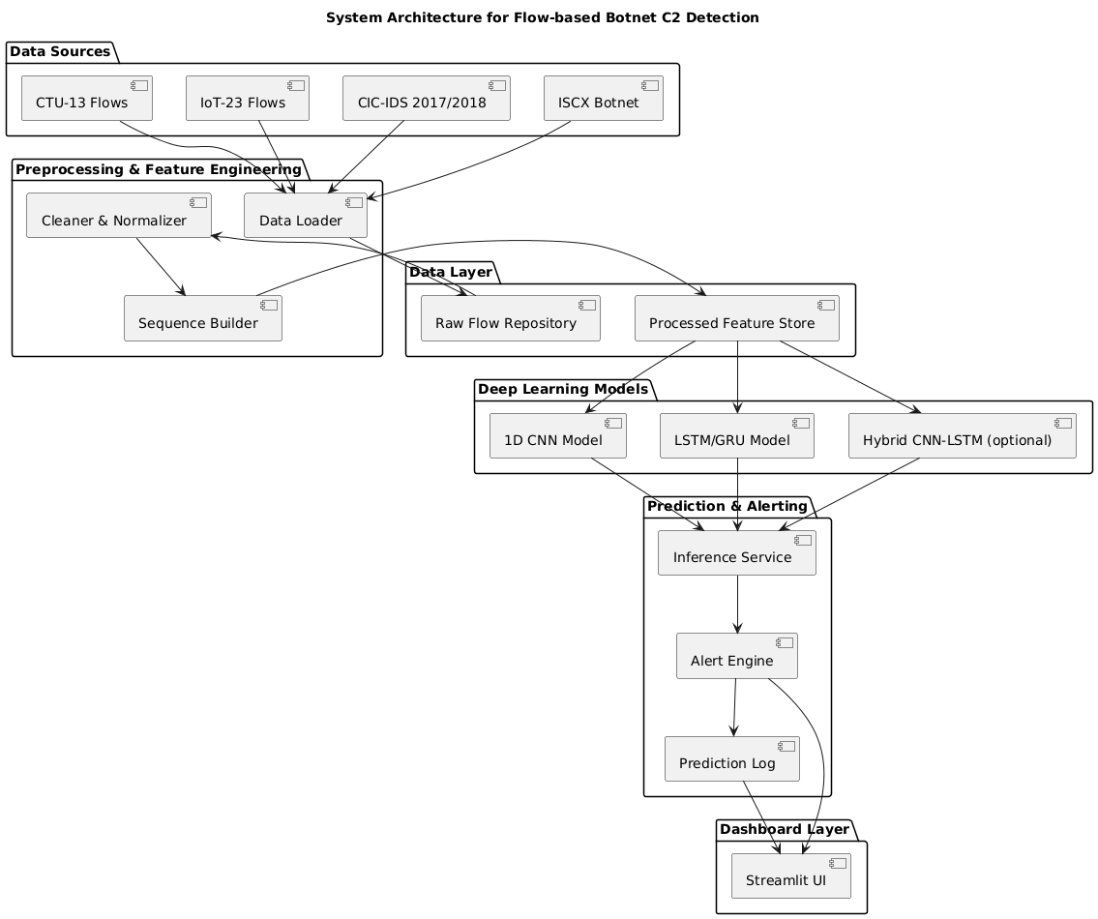
4.4 Preprocessing and Feature Engineering
The Preprocessing and Feature Engineering Layer transforms raw flow records into model-ready feature sequences. The first phase performs cleaning and normalization: missing values are handled according to predefined rules, numeric attributes are scaled using methods such as Z-score or MinMax scaling, and categorical attributes (such as protocol type) are encoded numerically. Label mapping is also applied at this stage, ensuring consistency between datasets and defining which labels are used for training.
The second phase constructs sequences of packet-level or time-bin features for each flow. For each flow, the system obtains or reconstructs a list of packet timestamps, packet sizes, and directions. From this list, it computes inter-arrival times and optionally cumulative features such as running byte totals. These values form a time-ordered sequence of feature vectors. Since flows differ in length, the sequence for each flow is padded with neutral values or truncated to a fixed length. The final output of this layer is a set of aligned sequences and labels stored in a processed feature repository, ready to be consumed by the deep-learning models.
4.5 Deep-Learning Model Layer
The Deep-Learning Model Layer encapsulates all logic related to model definition, training, evaluation, and persistence. It supports at least two primary architectures: a 1D CNN and an LSTM/GRU-based recurrent model. The 1D CNN processes sequences using convolutional filters that slide over the time dimension, learning local patterns in packet sizes and timings. Pooling layers and non-linear activations then compress these patterns into higher-level representations useful for classification.
The recurrent model ingests the same sequences but focuses on long-range dependencies. LSTM or GRU cells maintain internal state across time steps, allowing the network to capture periodic heartbeats, multi-stage handshakes, or delayed responses characteristic of C2 traffic. Optionally, a hybrid CNN-LSTM architecture stacks convolutional layers for local feature extraction followed by recurrent layers for temporal aggregation. Training routines in this layer handle data batching, loss computation, optimization, early stopping based on validation performance, and saving of best-performing model checkpoints.
4.6 Prediction and Alerting Layer
The Prediction and Alerting Layer connects trained models to incoming flow data. Its inference component loads a selected model along with the associated preprocessing configuration and exposes a simple interface (for example, a function or web endpoint) that accepts raw flow records. When a new batch of flows arrives, the layer internally calls the same preprocessing and sequence construction routines used during training, guaranteeing that the feature representations are consistent. The model then generates class probabilities and predicted labels for each flow.
On top of raw predictions, the alerting component applies configurable policies. It compares predicted probabilities against thresholds tailored for each class or group of classes. For example, a high threshold might be set for raising C&C or HeartBeat alerts to minimize false positives, while a more permissive threshold may be appropriate for generic “suspicious” flags. Alerts include flow metadata, predicted label, model confidence, and timestamp, and are written to an alert log or database. The alerting layer also maintains summary statistics, such as alert counts by type and time window, which are later consumed by the dashboard.
4.7 Dashboard and User Interaction
The Dashboard Layer provides SOC analysts and researchers with a visual interface to explore data, understand model behavior, and monitor live detections. Implemented using a web framework such as Streamlit, it offers several key views. A dataset overview page shows basic statistics, including the number of flows, label distributions, and feature histograms. A model performance page presents evaluation metrics, confusion matrices, and plots that summarize how well the model distinguishes between benign and malicious traffic.
Another crucial view is the real-time or batch prediction panel, which lists recently processed flows alongside their predicted labels and confidence scores. Analysts can filter by label, time interval, or source/destination attributes, and drill down into individual flows to inspect their metadata. An alerts page focuses on flows that have been flagged as C2-related, indicating severity and providing short textual explanations such as “small periodic packets consistent with HeartBeat” or “large download from known suspicious host.” These explanations are derived from simple rules that interpret model outputs and selected feature values, improving the interpretability of automated decisions.

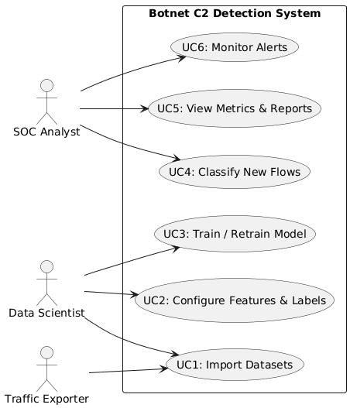

4.8 Detailed Workflow: C2 Detection Pipeline
From an operational standpoint, the system follows a coherent workflow whenever new data is processed. First, raw flows are received either as batch files or as streamed exports from network devices. The Data Layer stores these flows and records their source and capture context. Next, the Preprocessing Layer loads the new data, applies cleaning and normalization, and then passes flows to the sequence builder, which generates fixed-length feature sequences.
Once sequences are constructed, they are submitted to the inference component alongside the selected model identifier. The model computes probabilities for each target class and returns predictions to the alerting logic. The Alert Engine evaluates each prediction against defined thresholds and policies, creates alert entries where required, and writes both alerts and benign predictions to the prediction log. The Dashboard periodically queries these logs and presents updated views to analysts. This end-to-end process ensures that every step—from raw flow to alert—is consistent with the training configuration and fully traceable.
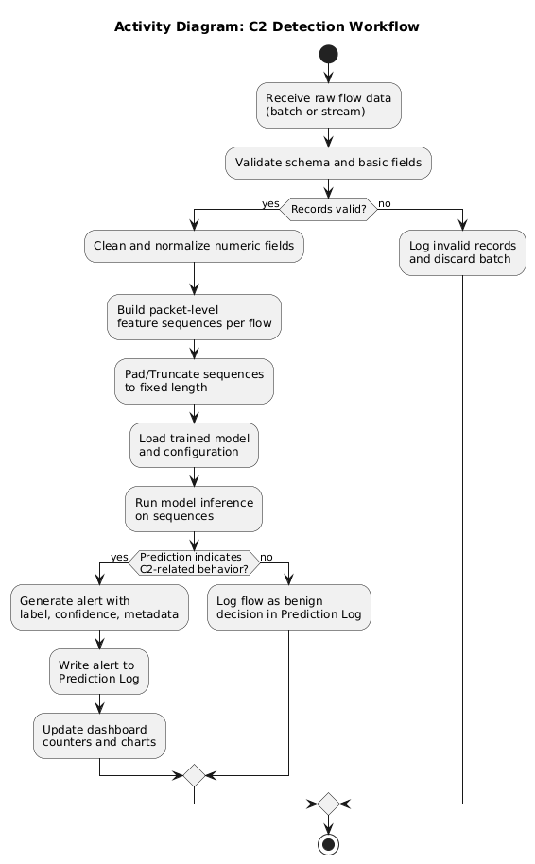
4.9 Runtime Interaction: Flow Classification Sequence
At runtime, a typical interaction begins when an analyst or automated process submits flows for classification through the dashboard. The dashboard forwards the request to the inference service, which hands off the raw data to the preprocessing component. After preprocessing, the resulting sequences are sent to the loaded deep-learning model, which returns class probabilities. The inference service then forwards these probabilities to the alert engine.
The alert engine evaluates whether each flow represents benign behavior or some form of malicious activity. For flagged flows, it creates structured alert objects that are stored in an alert database and returned to the dashboard as part of the response. The dashboard then updates the user interface, showing a table of flows with their predicted labels, risk levels, and concise explanations. This sequence of calls and responses is designed to be stateless at the API level, relying on stored configurations to reconstruct the exact preprocessing and model context required.
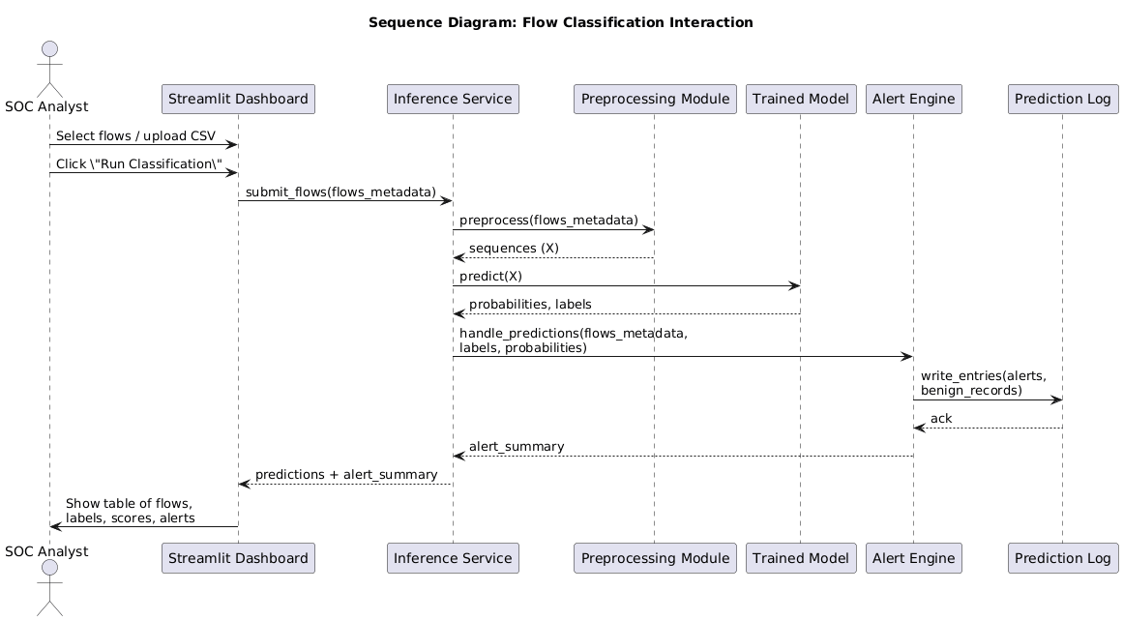
4.10 Static Structure: Core Classes and Responsibilities
The internal structure of the system can be organized into a set of core classes or modules, each with clear responsibilities. A data loader class or module is responsible for reading raw datasets according to configuration files and exposing unified data frames or records. A preprocessor class handles cleaning, normalization, and label encoding. A sequence builder encapsulates all logic related to constructing fixed-length sequences from flow or packet information.
On the modeling side, a model manager class builds specific architectures (1D CNN, LSTM/GRU, or hybrids), orchestrates training loops, evaluates models against validation data, and saves model artifacts. An inference service wraps the selected model together with its preprocessing pipeline and exposes prediction methods. An alert engine class takes prediction outputs, applies thresholds and policies, and writes alerts and prediction records to storage. Finally, a dashboard controller class acts as the gateway between the web front end and backend components, providing methods to fetch statistics, metrics, recent alerts, and sample predictions.
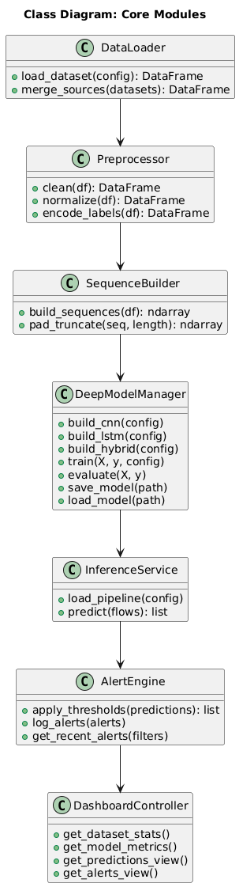
4.11 Components and Deployment Considerations
From a deployment perspective, the system can be decomposed into several components that may run as separate processes or services. A data ingestion component is responsible for periodically importing new flow logs into the raw data store. A preprocessing component can be run offline to prepare training datasets or inline as part of an inference pipeline, depending on performance requirements. A model training component executes training jobs, possibly on dedicated hardware, and updates the model repository when new models are validated.
An inference API component exposes a lightweight interface to accept classification requests and return predictions. An alert and logging component manages persistent storage of alerts and prediction metadata. The dashboard component runs as a web application on analyst workstations or a shared server, connecting to the alert store and inference API as needed. Databases or storage services are used to hold raw data, processed features, trained models, and alerts. This modular view allows organizations to scale or secure each part independently.
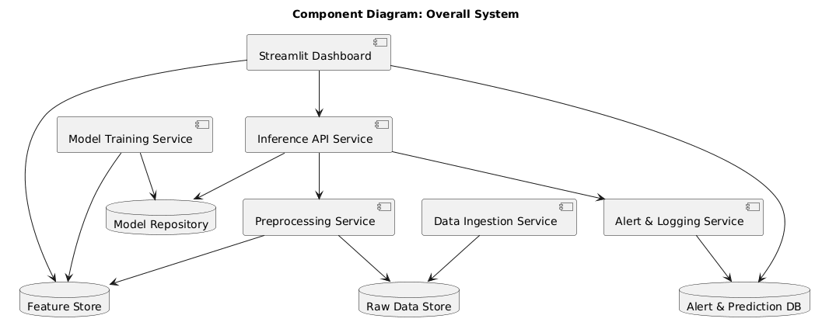
4.12 Example Deployment Environment
In a typical deployment scenario, the main detection pipeline runs on a server in the data center or cloud environment where flow data is collected. This server hosts the preprocessing logic, the trained deep-learning models, the inference API, and the alert and logging subsystem. Raw datasets and model backups may be stored on a shared object storage service or a dedicated file server to support retraining and auditing.
SOC analysts access the system from their workstations through the dashboard. The dashboard connects to the alert database to display recent detections and can query the inference API for on-demand classification of selected flows. Network devices such as firewalls or routers export flow logs to the data ingestion pipeline, which feeds processed flows into the detection server at scheduled intervals or in near real time. This deployment arrangement balances computational load, data locality, and usability.
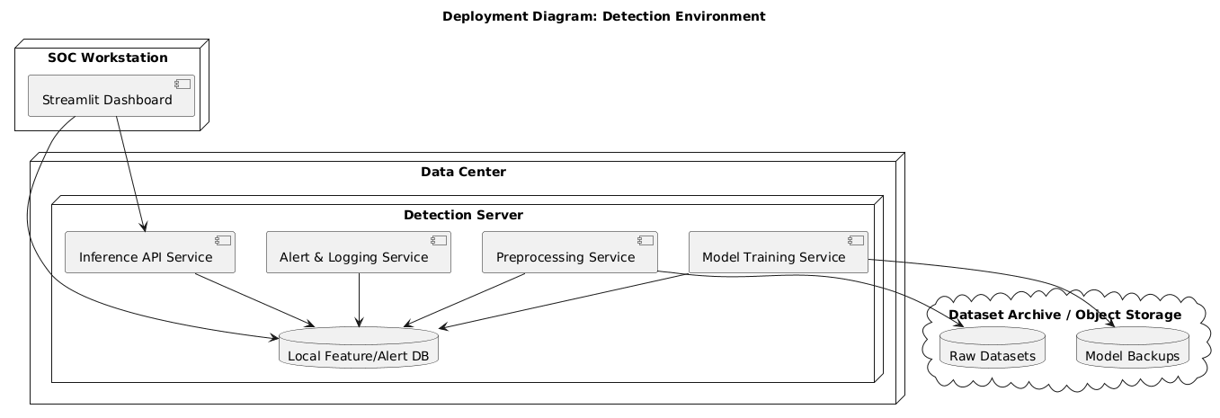

Chapter 5: System Implementation
5.1 Overview of Implementation Strategy
The implementation of the botnet C2 detection system follows the modular architecture defined in the design phase. Each logical layer—data ingestion, preprocessing and feature engineering, deep-learning models, prediction and alerting, and dashboard—corresponds to one or more Python modules or packages. The project is organized to support both experimentation (via notebooks and scripts) and deployment (via reusable modules and a dashboard application). Configuration files drive most dataset paths, feature selections, and model hyperparameters so that core code remains generic and easy to maintain.
The technology stack is centered on Python 3. The implementation uses libraries such as NumPy for numerical operations, Pandas for tabular data handling, Scikit-learn for preprocessing utilities and evaluation metrics, and TensorFlow/Keras or PyTorch for deep-learning models. Visualization and user interaction are provided through Streamlit, which offers a simple way to create a web-based dashboard without heavy front-end development. The code structure is designed so that new datasets, features, and models can be integrated with minimal changes to existing modules.
5.2 Project Structure and Modules
A typical directory layout for the implementation is as follows (names can be adapted to local conventions):
- data/ – raw flow files (CSV or parquet) from CTU-13, IoT-23, CIC-IDS, ISCX, and any custom captures.
- processed/ – preprocessed feature arrays and label files ready for training and evaluation.
- configs/ – YAML or JSON configuration files specifying dataset locations, feature columns, label mappings, and model hyperparameters.
- src/ – main source code for the system:
  - data_loader.py – dataset ingestion and merging logic.
  - preprocess.py – cleaning, normalization, and label encoding.
  - sequence_builder.py – construction of fixed-length sequences from flows.
  - models_cnn.py – 1D CNN architecture definitions.
  - models_lstm.py – LSTM/GRU architecture definitions.
  - train.py – orchestration of training and evaluation runs.
  - inference.py – reusable inference pipeline for new flows.
  - alerts.py – alert generation and logging utilities.
- dashboard/ – Streamlit application files:
  - app.py – main dashboard entry point.
  - views/ – optional sub-modules for organizing dashboard pages.
- notebooks/ – Jupyter notebooks for exploratory data analysis, feature inspection, and experimental runs.
- models/ – saved model weights and metadata.
- logs/ – logs of training runs and alerts.
This structure separates reusable core logic (in src/) from experimental artifacts (in notebooks/) and deployment-oriented components (in dashboard/).
5.3 Data Loading and Configuration
The implementation begins with configuration files that define dataset parameters. A typical configuration includes:
- Paths to raw data files for each dataset (for example, ctu13_scenario3.csv, iot23_scenario1.csv).
- Column mappings from dataset-specific field names to canonical names such as src_ip, dst_ip, src_port, dst_port, protocol, start_time, end_time, num_pkts, num_bytes, and label.
- Label mappings that unify behavior semantics across datasets (for example, mapping C&C to C2, CNC to C2, or merging several malicious categories into a single “Malicious” label for binary classification).
- Train/validation/test split ratios and random seeds for reproducibility.
The data_loader.py module reads these configurations and implements functions to:
- Load each dataset into a Pandas DataFrame using appropriate parsing options (such as timestamp formats and separators).
- Rename columns according to the canonical schema.
- Filter flows based on criteria like minimum packet count, valid labels, or protocol types of interest.
- Concatenate multiple datasets into a single DataFrame for joint training or maintain them separately for cross-dataset evaluation.
By centralizing dataset logic in the data loader, the rest of the pipeline can operate on a consistent set of columns, regardless of the original dataset format.
5.4 Preprocessing: Cleaning, Normalization, and Label Encoding
The preprocessing module (preprocess.py) implements several steps to prepare the data for feature extraction and modeling. First, it handles missing values by:
- Dropping non-essential records with extensive missingness.
- Filling missing numeric fields with sensible defaults or summary statistics (for example, median).
- Ensuring that all required features are present before further processing.
Next, numeric columns such as packet counts, byte counts, and durations are normalized. Common strategies include:
- Z-score normalization (subtract mean and divide by standard deviation) to center and scale features.
- MinMax scaling to map features into a fixed interval, typically, which can help when using activation functions like sigmoid.Resume_Parser_and_Job_Recommendation-Final-Documentation.docx​
Label encoding is also performed here. For binary classification, labels may be mapped to 0 (“Benign”) and 1 (“Malicious/C2-related”). For multi-class classification, a label encoder translates textual labels (for example, Benign, C&C, HeartBeat, FileDownload) into integer indices. Class mappings are stored so that the same encoding can be reused in evaluation and inference.
Finally, preprocessing includes splitting the dataset into training, validation, and test sets. Stratified splitting is used when possible to preserve class proportions across splits, which is particularly important in imbalanced datasets where malicious flows are rare. The indices or masks defining each split are saved for reproducibility.
5.5 Sequence Construction and Feature Arrays
The sequence_builder.py module focuses on transforming cleaned flows into fixed-length sequences suitable for deep-learning models. Its implementation depends on the level of detail available in the data:
- When packet-level records are available or can be reconstructed, the module aggregates packets by flow and sorts them by timestamp. For each packet, it records features such as size, inter-arrival time (difference between current and previous packet timestamp), and direction flag (for example, +1 for source to destination, −1 for reverse).
- When only aggregate flow fields are available, the module may approximate sequences by splitting the flow duration into time bins and distributing bytes and packets proportionally or using synthetic distributions informed by available statistics.
Once a raw sequence of feature vectors is assembled for each flow, the module enforces a fixed length L (for example, 100 steps). If a flow has fewer than L packets or time bins, the sequence is padded with zeros or a neutral vector and a mask is optionally maintained to indicate real versus padded positions. If a flow has more than L steps, it is truncated, either from the end or by sampling key segments (for example, the first and last parts of the flow).
The outcome of this process is:
- A NumPy array X of shape (N, L, F), where N is the number of flows and F is the number of features per time step.
- A label array y of shape (N,) or (N, C) depending on whether labels are encoded as integers or one-hot vectors for C classes.
These arrays are serialized in the processed/ directory for reuse by the training and evaluation scripts.
5.6 Model Implementation: 1D CNN and LSTM/GRU
The deep-learning models are implemented in models_cnn.py and models_lstm.py. Both modules rely on a consistent interface so that the training script can switch between architectures via configuration.

5.6.1 1D CNN Model
The 1D CNN model is usually constructed with:
- An input layer specifying the sequence shape (L, F).
- One or more convolutional blocks, each comprising:
  - A 1D convolution layer with a specified number of filters and kernel size.
  - An activation function such as ReLU.
  - Optional batch normalization.
  - Max-pooling to reduce the temporal dimension.
- A flattening layer to convert the final feature maps into a vector.
- One or more dense layers with dropout for regularization.
- An output layer with softmax (for multi-class) or sigmoid (for binary) activation.
Hyperparameters such as the number of filters, kernel sizes, pooling sizes, dense layer sizes, dropout rates, and learning rate are provided in a configuration file and passed into the model-building function.
5.6.2 LSTM/GRU Model
The LSTM/GRU model follows a similar pattern but focuses on recurrent layers:
- An input layer for sequences of shape (L, F).
- One or more recurrent layers (LSTM or GRU), possibly bidirectional, with configurable hidden sizes and dropout.
- A final dense layer mapping the last hidden state (or a pooled representation) to class logits or probabilities.
Options include returning the full sequence of hidden states or only the final state, depending on whether additional pooling is desired. The model also uses standard loss functions such as binary cross-entropy or categorical cross-entropy, and optimizers such as Adam.
5.7 Training and Evaluation Workflow
The train.py script orchestrates the end-to-end training process. When invoked with a configuration file, it typically performs the following steps:
- Load the configuration that specifies dataset paths, sequence length, feature choices, model type (CNN, LSTM, or hybrid), and training hyperparameters.
- Use the data loader and preprocessing modules to obtain the cleaned DataFrame, normalized features, and encoded labels.
- Call the sequence builder to create the (X, y) arrays for training, validation, and test sets.
- Instantiate the selected model architecture with the configured hyperparameters.
- Compile the model with an appropriate loss function and optimizer, and define metrics such as accuracy, precision, recall, and F1-score.
- Train the model using mini-batches, monitoring validation performance at the end of each epoch. Early stopping and model checkpointing callbacks are used to prevent overfitting and to save the best performing model.
- After training, evaluate the model on the held-out test set and compute detailed metrics, including confusion matrices and per-class precision and recall.
5.8 Inference Pipeline and Alert Generation
The inference.py module packages preprocessing, sequence building, and model prediction into a single callable pipeline. This module loads:
- The chosen model from models/.
- The associated configuration file specifying sequence length, feature types, and label encodings.
When given raw flow data (either as a DataFrame or JSON payload), the inference pipeline:
- Applies the same cleaning and normalization as during training.
- Builds sequences with the same length and feature ordering.
- Passes the sequences through the loaded model to obtain class probabilities.
- Converts probabilities to labels using the stored label encoder.
The alerts.py module then takes these predictions and applies alerting rules. For each flow, it:
- Compares the predicted probabilities with thresholds defined per class or per group of classes (for example, higher thresholds for C&C or HeartBeat).
- Assigns a severity level based on both label type and confidence score.
- Constructs alert objects containing flow metadata, label, confidence, and a timestamp.
Alerts and benign predictions are written to a prediction log, typically a CSV file or database table in the logs/ directory. This log serves as the primary data source for the dashboard.
5.9 Dashboard Implementation with Streamlit
The dashboard/app.py file implements the main Streamlit application for interacting with the system. The dashboard is structured into multiple pages or sections, for example:
- Overview Page:
  - Displays total number of flows analyzed, number of alerts generated, and current model name and version.
  - Shows high-level charts such as bar plots of alerts by type and time series of alert volumes.
- Dataset Explorer Page:
  - Reads summary statistics from the processed data or configuration.
  - Displays label distributions, example flows, and feature histograms.
  - Allows analysts to filter by dataset, label, or time period.
- Model Performance Page:
  - Shows metrics loaded from the training log, including accuracy, precision, recall, and F1-score.
  - Plots confusion matrices and ROC curves, offering insight into which classes are hardest to distinguish.
- Real-Time Predictions / Alerts Page:
  - Continuously reads the prediction log and refreshes a table of recent flows and their predicted labels.
  - Highlights alerts using color coding based on severity.
  - Provides simple explanations for each alert using human-readable rules that refer to model output (for example, “High C2 probability with short periodic flows”).
The dashboard interacts with backend modules through shared files or via function calls if run in the same process. In more advanced deployments, HTTP APIs can be used instead.
5.10 Configuration, Logging, and Reproducibility
A critical aspect of system implementation is ensuring that experiments and deployments are reproducible. To this end, the project:
- Uses configuration files to control dataset selections, feature definitions, model hyperparameters, training schedules, and alert thresholds.
- Logs training runs with timestamps, configuration snapshots, and performance metrics, enabling precise reproduction of results.
- Seeds random number generators (for example, in NumPy and the deep-learning framework) where supported, to reduce variability between runs.
- Includes version identifiers in model filenames and metadata so that analysts know exactly which model produced a given set of predictions.
Logging is also used at runtime to record errors, warnings, and informational messages from each module. For example, the data loader logs how many records were dropped due to missing data, and the inference pipeline logs when a batch of flows fails preprocessing due to unexpected schema changes.
5.11 Security and Operational Considerations
While this project primarily targets an academic and experimental setting, the implementation includes several practices that ease transition toward real deployments. Access to raw data directories and model files can be restricted using operating system permissions. If the inference pipeline is exposed as a network service, authentication and transport-layer security can be added at the API layer.

Chapter 6: System Testing
6.1 Objectives of Testing
System testing for the botnet C2 detection project focuses on validating both correctness and robustness of the complete pipeline, from data ingestion through deep-learning classification to alert generation and visualization. The primary objectives are: to ensure that each module behaves as designed under normal and abnormal conditions; to verify that data transformations are consistent and reproducible; and to assess the practical detection performance of the models using representative benchmark datasets. Testing must also evaluate the system’s behavior in edge scenarios, such as very short flows, rare labels, or incomplete records, which are common in real network environments.
At a higher level, system testing aims to demonstrate that the integrated system can detect C2-related behaviors, such as C&C, HeartBeat, DDoS coordination, and malicious file downloads, with acceptable accuracy and false-positive rates. This assessment goes beyond academic metrics and considers operational concerns such as alert volume, interpretability of results, and responsiveness of the dashboard. The testing strategy combines unit tests, integration tests, functional tests, and empirical evaluation on CTU-13, IoT-23, and related datasets to provide a comprehensive validation.
6.2 Testing Strategy and Categories
The testing process is organized into several categories aligned with the project’s modular architecture. Unit testing validates individual functions or classes, such as data loaders, preprocessors, and sequence builders, to ensure that they handle expected inputs and fail gracefully on malformed data. Integration testing examines how modules interact when combined, for example, verifying that the output of preprocessing matches the input expectations of the deep-learning models. System testing validates the end-to-end flow from raw dataset to dashboard, simulating typical user workflows.
In addition, performance and stress testing evaluate how the system behaves under load, particularly when processing large batches of flows or frequent inference requests. Regression testing is used to confirm that changes to models or preprocessing pipelines do not inadvertently degrade previously validated behavior. Finally, user-oriented acceptance testing focuses on the dashboard and alerting layer, confirming that analysts can interpret and act upon model outputs in a natural and effective way. Together, these categories ensure both technical soundness and practical usability.
6.3 Unit Testing of Core Modules
Unit tests are written for each core module in the src/ directory. For the data loader, tests verify that configuration files are correctly parsed, that datasets are loaded with the expected columns, and that column renaming and filtering operations produce a canonical schema. Test cases include small synthetic CSV files with known content and edge cases such as missing columns or unexpected label values. The goal is to guarantee that downstream components receive consistent DataFrames regardless of dataset origin.
For the preprocessing module, unit tests validate cleaning, normalization, and label encoding. Synthetic DataFrames are created with deliberate missing values, extreme numeric values, and mixed label formats to check that the cleaning logic behaves as intended. Normalization functions are tested by confirming that output feature distributions have the expected ranges or standardized properties. Label encoders are verified by round-trip testing: encoding a set of labels and then decoding them must recover the original labels. Similar unit tests are implemented for the sequence builder, ensuring that sequences are constructed in the correct order, padded or truncated to the specified length, and shaped consistently for use by the models.
6.4 Integration Testing of the Preprocessing and Model Pipeline
Integration tests focus on the interaction between preprocessing, sequence building, and model training. A typical integration test constructs a small but realistic dataset, runs it through the full preprocessing pipeline, and then feeds the resulting feature arrays into a minimal model. The test checks that shapes and data types match the model’s input specification and that there are no discrepancies between training and inference paths.
Another integration scenario ensures that the same preprocessing configuration is used consistently across modules. For example, a test may run preprocessing and sequence construction twice with the same configuration and compare the resulting arrays for equality, confirming reproducibility. Integration tests also check that label mappings remain consistent: the labels used in the model’s output layer must correspond exactly to the encoded labels created during preprocessing. This kind of testing is essential to avoid subtle mismatches that could invalidate evaluation results or mislabel alerts.
6.5 Functional Testing of Inference and Alerting
Functional testing verifies that the inference and alerting modules behave correctly under realistic usage patterns. Inference tests simulate the submission of new flow records, either from stored CSV samples or inline JSON payloads, and check that the pipeline returns predictions in the expected format. These tests confirm that preprocessing is invoked automatically, that the correct trained model is loaded, and that predictions are accompanied by probabilities or confidence scores.
Alerting tests examine how raw predictions are converted into alerts. Test cases cover scenarios where predicted probabilities fall above or below configured thresholds for different classes. For example, a flow with a high predicted probability for a C&C label should result in a high-severity alert with appropriate metadata, while a low-confidence prediction should either be suppressed or recorded as benign according to policy. Edge tests verify behavior when key fields are missing or when the model cannot produce a prediction due to malformed input; in these cases, the system should fail safely and log an appropriate warning rather than silently misclassifying the flow.
6.6 Dashboard and User Interface Testing
Testing of the Streamlit dashboard focuses on ensuring that analysts can reliably access and interpret system outputs. Interface tests verify that pages for overview, dataset exploration, model performance, and alerts load correctly, display the expected widgets and plots, and handle typical user interactions such as filtering, sorting, and selecting time ranges. These tests can be partially automated using browser-driven testing tools, but manual testing is also important to assess usability.
Data consistency between the backend and the UI is another key focus. For example, when the prediction log is updated with new alerts, the dashboard must reflect these changes without stale data or mismatched counts. Testing includes scenarios where the log file is temporarily unavailable or corrupted, ensuring that the dashboard displays clear error messages rather than failing silently. The responsiveness of the interface under moderate data volumes is also evaluated to ensure that analysts are not hindered by slow or unresponsive views.

6.7 Test Scenarios and Edge Cases
Beyond standard usage, the system is tested against a variety of edge cases that commonly arise in network telemetry. One class of scenarios involves very short flows, such as those with only one or two packets. These flows present challenges for sequence-based models, which expect fixed-length inputs; tests confirm that such flows are correctly padded and that the model’s outputs are handled appropriately. Another scenario involves very long flows, where truncation strategies may impact classification; tests compare different truncation methods to verify that they do not introduce systematic bias.
Additional edge cases include flows with ambiguous or rare labels (for example, seldom-seen botnet families), flows with inconsistent timestamps, and flows with unexpected or previously unseen protocol values. In each case, tests verify that preprocessing does not crash, that labels are either correctly mapped or gracefully rejected, and that the alerting system marks uncertain cases in a way that does not mislead analysts. These edge tests are essential to ensure that the system remains robust when deployed on real, messy network data rather than only on curated academic datasets.
6.8 Evaluation Methodology and Metrics
The core empirical evaluation of the detection models uses benchmark datasets such as CTU-13 and IoT-23, which provide labeled flow-level traffic covering benign behavior and multiple malicious activities. The evaluation methodology typically involves splitting each dataset into training, validation, and test sets, with the test set reserved exclusively for final performance reporting. Cross-dataset experiments can also be conducted, where models trained on one dataset are tested on another to assess generalization across environments.
Standard classification metrics are computed, including accuracy, precision, recall, and F1-score. Precision and recall are particularly important for C2 detection: high precision ensures that most alerts are truly malicious, reducing alert fatigue, while high recall minimizes missed detections of C2 flows. Confusion matrices provide a detailed view of which classes are frequently confused, for example, whether HeartBeat traffic is sometimes misclassified as benign or whether DDoS traffic is confused with generic Attack flows. Depending on the task formulation, additional metrics such as area under the receiver operating characteristic curve (AUC-ROC) and false alarm rate can be reported.
6.9 Experimental Setup and Results Overview
Experiments are conducted in a controlled environment with commodity hardware, such as an Intel i5 or similar processor, 8–16 GB of RAM, and optional GPU acceleration for deep-learning training. Training runs vary in duration depending on dataset size, sequence length, and model complexity. Typically, multiple configurations are tested, including pure 1D CNN models, pure LSTM/GRU models, and hybrids, to identify trade-offs between accuracy and computational cost.
While specific numerical results depend on dataset splits and hyperparameters, typical trends can be observed. CNN-based models often converge faster and require less memory, making them attractive for resource-constrained environments, while LSTM/GRU models sometimes provide improved recall on temporally subtle behaviors such as HeartBeat. Hybrid models can offer balanced performance, capturing both local size patterns and long-range temporal structure. Evaluation on behavior-specific labels often reveals that high-volume attacks (for example, DDoS and large FileDownload) are easier to detect than low-volume C&C heartbeats, highlighting the importance of careful threshold tuning and potential future work on specialized architectures.

6.10 Error Analysis and False Positives/Negatives
A critical component of system testing is qualitative error analysis, which goes beyond aggregate metrics. For false positives, the analysis focuses on benign flows that the model incorrectly labels as C2-related. Many such cases involve legitimate periodic traffic such as monitoring probes, health checks, or software update checks that share superficial similarities with botnet heartbeats. Examining these flows helps refine both feature engineering and alerting thresholds; in some cases, additional contextual features (for example, known trusted endpoints) can be used to reduce false alarms.
For false negatives, the emphasis is on malicious flows that the model fails to detect. These may include carefully obfuscated C2 communications that closely mimic benign traffic patterns or rare behaviors underrepresented in the training data. Error analysis in this category guides dataset augmentation, rebalancing strategies, and potential model architecture changes. For example, if many false negatives occur for a specific label such as HeartBeat, targeted oversampling or specialized sub-models for that behavior may be warranted. The outcome of error analysis is a list of actionable insights that inform iterative improvements to the system.
6.11 Regression and Continuous Testing
As the project evolves, models, features, and configurations may change, making regression testing essential. Automated test suites are run whenever significant code changes or model retrainings occur, verifying that previous test cases still pass and that performance on key datasets does not degrade unexpectedly. Baseline metrics are stored, and new runs are compared against these baselines; a significant drop in recall for C2-related labels, for example, would trigger an investigation before deployment of the updated model.
Continuous integration practices can be adopted to run unit and integration tests on each code commit. Over time, additional test cases are added based on newly discovered edge scenarios or operational feedback from analysts. This ongoing testing process helps maintain system quality and stability, ensuring that improvements in one area do not inadvertently introduce vulnerabilities or regressions elsewhere.

Chapter 7: Screenshots
7.1 Overview of Visual Walkthrough
This chapter describes the visual behavior of the botnet C2 detection system as experienced through the Streamlit-based dashboard and related interfaces. The narrative follows the typical analyst journey from initial dataset inspection through model evaluation to real-time alert monitoring. Each subsection corresponds to a screenshot that will later be captured from the running system and inserted at the appropriate place in the final document. Together, these views provide concrete evidence that the implemented pipeline is functional, interactive, and usable in an operational setting.
The walkthrough assumes that the detection server and dashboard have been started and that at least one trained model and associated prediction log are available. The dashboard runs in a web browser and makes use of standard Streamlit UI elements such as sidebars, select boxes, file uploaders, tables, and charts. The emphasis is on clarity and simplicity: analysts should be able to understand the state of the system and the nature of recent detections at a glance, without needing to inspect raw logs manually.
7.2 Dataset Loading and Summary Views
The first visual that an analyst encounters is the dashboard’s home or overview page. This page typically displays a clear title, a brief description of the application, and a set of high-level counters summarizing the current data and model state. Example counters include the total number of flows loaded into the system, the number of benign and malicious flows in the active dataset, and the name and version of the model currently selected for inference. A navigation menu or sidebar allows switching between pages such as “Dataset Explorer,” “Model Performance,” and “Alerts.”
When the analyst navigates to the dataset statistics view, the interface allows selection of one or more datasets via dropdowns or checkboxes (for example, choosing between CTU-13, IoT-23, CIC-IDS, or a combined corpus). Below the selector, the dashboard renders summary charts that show the distribution of labels across the chosen dataset. Bar charts or pie charts present counts or proportions for classes such as Benign, Attack, C&C, HeartBeat, DDoS, FileDownload, Mirai, Okiru, Torii, and PartOfAHorizontalPortScan. Accompanying textual summaries highlight issues such as strong class imbalance or the relative scarcity of particular behaviors, guiding analysts and data scientists as they plan training or retraining runs.
7.3 Feature Exploration and Flow Inspection
A dedicated section of the dashboard is used to explore feature distributions and inspect individual flows. The feature exploration panel typically contains several plots arranged in a grid layout, each visualizing a key numeric feature. Examples include histograms of flow duration, total bytes, and packet counts, as well as violin or box plots comparing these features across labels. Controls at the top of the panel allow the user to filter by label (for example, viewing only benign versus only C2-related flows) or adjust the range and binning of the plots. This visual analysis helps validate preprocessing decisions and reveals differences between benign and malicious traffic, such as systematically shorter durations for certain scanning behaviors or characteristic size profiles for file downloads.
Next to or below the distribution charts, a flow inspection table lists a subset of flows with columns for identifiers, IP addresses, ports, protocol, timestamps, and ground-truth label. The analyst can sort and filter this table by any column and click on a specific row to open a detailed flow view. In the detail view, all stored metadata for that flow is displayed, and a small time-series plot can show the per-packet sequence, such as packet size versus time or cumulative bytes over time. This visualization allows the analyst to correlate the abstract model inputs with intuitive traffic patterns, aiding in model debugging and in explaining why certain flows might be considered suspicious.
7.4 Model Training and Evaluation Outputs
The “Model Performance” section of the dashboard presents the results of training and evaluation runs. One of the central elements is a pair of line charts plotting training and validation loss and accuracy as functions of training epoch. These charts are often displayed side by side, with tooltips that reveal exact values when the user hovers over specific epochs. Dropdowns or radio buttons allow switching between different model runs, such as a pure 1D CNN, a pure LSTM/GRU, and a hybrid CNN-LSTM architecture. This visual feedback helps users assess convergence behavior, identify overfitting (for example, when validation loss starts increasing while training loss continues to decrease), and compare alternative architectures.
Another important visualization in this section is the confusion matrix, rendered as a colored grid where rows correspond to true labels and columns to predicted labels. Each cell shows counts or normalized percentages, and a color scale indicates the magnitude of each value. For binary classification, the matrix clearly shows true positives, true negatives, false positives, and false negatives. For multi-class formulations, it reveals which specific labels (such as HeartBeat or FileDownload) are most frequently misclassified. Adjacent to the confusion matrix, the dashboard prints numeric metrics such as precision, recall, F1-score, and overall accuracy, optionally broken down per class. Analysts can use this information to tune thresholds, focus on problematic classes, and decide whether the current model is satisfactory for deployment.
7.5 Real-Time Prediction and Alert Screens
The real-time prediction or “Live Detection” page supports operational use. At the top of this page, a control panel allows the analyst to upload a new batch of flow records via a file uploader element or to request classification of flows recently ingested from the network. Options may exist to choose the active model, specify whether predictions should be appended to the existing log, and adjust confidence thresholds used for alerting. Once the user initiates prediction, a progress indicator shows that the flows are being preprocessed and classified, reflecting the underlying pipeline described in earlier chapters.
Below the control panel, a prediction results table lists each processed flow along with key attributes and the model’s decision. Typical columns include flow ID, source and destination endpoints, protocol, predicted label, predicted probability or score, and a binary flag indicating whether an alert was generated. Color coding or icons highlight flows labeled as C2-related or otherwise malicious. Additional filtering controls let the analyst show only alerts, only benign predictions, or only flows above a certain confidence threshold. This interface enables quick triage of new traffic and forms the basis for practical response workflows, such as exporting suspicious flows to external incident management tools.
An alerts summary panel completes the operational view. It aggregates alerts over a configurable time window and displays metrics like total alerts, alerts by label type, and alerts by severity level. Visual elements such as stacked bar charts, timelines, or simple counters give a concise picture of current threat activity. For instance, a spike in C&C or HeartBeat alerts over a short period may indicate an active botnet campaign, while steady low-level DDoS alerts may point to ongoing abuse. The analyst can click on specific categories in the chart to filter the alert table below, making it easy to drill down from high-level trends to individual flows and their detailed metadata.
7.6 Error Handling and Edge-Case Demonstrations
To demonstrate resilience, the dashboard also shows clear behavior in the presence of invalid inputs and low-activity states. When a user attempts to upload a dataset with missing or misnamed columns, the application displays an error banner describing which fields were not found or which schema constraints were violated. The interface may suggest corrective actions, such as checking the header row or using a supported export format, rather than failing silently. Similarly, if the inference service cannot load a requested model or encounters a configuration mismatch, the dashboard reports this and prevents the user from running predictions until the issue is resolved, preserving the integrity of results.
In periods where no new alerts are generated, the alerts page reflects this calmly. Summary charts show zero counts for the selected time range, and the alert table is empty or contains only benign entries. Instead of being confusing, this state reassures analysts that the system is not producing spurious detections in the absence of malicious activity. A brief informational message may clarify that the absence of alerts for a particular interval is expected when traffic is predominantly benign or when no new flow batches have been processed. These visual cues, combined with clear error and status messages, illustrate that the system provides transparent feedback in both normal and exceptional conditions.

Chapter 8: Conclusion & Future Work
8.1 Conclusion
The project demonstrated that flow-level deep learning can effectively detect botnet command-and-control (C2) traffic by exploiting temporal and structural patterns that persist even when payloads are encrypted or obfuscated. By converting each flow into a fixed-length sequence of features such as packet sizes, inter-arrival times, and direction flags, the implemented 1D CNN and LSTM/GRU models were able to separate benign traffic from behaviors associated with C&C, HeartBeat, DDoS, and malicious file downloads on benchmark datasets like CTU-13 and related corpora. The modular pipeline—from data ingestion and preprocessing through model training, inference, alerting, and visualization in a Streamlit dashboard—proved that such models can be embedded into a practical workflow suitable for security operations teams rather than remaining only as isolated research prototypes.
At the same time, the work highlighted important constraints. Generalization remains limited by the diversity and recency of training datasets; evolving botnet families and new C2 protocols may exhibit behaviors not fully captured by existing corpora. The fixed-length sequence representation introduces trade-offs for very short or very long flows, and the current system largely analyzes flows in isolation, without incorporating host-level histories or communication topology that are known to be informative for group-based botnet detection. Interpretability and lifecycle management also emerged as non-trivial challenges: deep networks can achieve high detection rates but require careful threshold tuning, drift monitoring, and explanatory mechanisms before they can be relied upon in production-grade intrusion detection contexts.
8.2 Future Work
Future work can enhance the system along three main axes: modeling, data/context, and deployment. On the modeling side, more advanced architectures such as attention-based CNN-LSTM hybrids or transformer-style sequence models could be explored to better capture long-range temporal dependencies and provide explainable attention weights over packets or time steps. Semi-supervised and self-supervised approaches are another promising direction, allowing the system to learn richer representations from large volumes of unlabeled traffic and then fine-tune on limited labeled C2 data, which is a common constraint in operational environments. Robust training techniques, including adversarial training and ensembling, could also improve resilience against attackers who deliberately manipulate timing and size patterns to evade sequence-based detectors.
From a data and context perspective, integrating graph- or topology-based features with flow sequences is a natural extension, as recent research shows that combining flow summaries with communication-graph information significantly improves botnet detection and characterization. Incorporating continuous learning mechanisms to handle concept drift—such as periodic retraining on recent traffic, federated learning across multiple organizations, or drift-aligned adaptation strategies—would help maintain accuracy as both benign usage and attacker behavior evolve. On the deployment side, future work can focus on production-ready integration: containerizing the inference and alerting services, adding authenticated APIs, and connecting the system to real NetFlow/IPFIX collectors, SIEM/SOAR platforms, and threat-intelligence feeds so that detections can drive automated containment and incident response in real networks.

REFRENCES
- S. García, M. Grill, J. Stiborek and A. Zunino, “An empirical comparison of botnet detection methods,” Computers & Security, vol. 45, pp. 100–123, 2014.
- Stratosphere IPS, “CTU-13 Dataset: A Labeled Dataset of Botnet, Normal and Background Traffic,” Czech Technical University in Prague, 2011.
- Stratosphere IPS, “IoT-23 Dataset: A Labeled Dataset of Malware and Benign IoT Traffic,” Czech Technical University in Prague, 2020.
- I. Sharafaldin, A. H. Lashkari and A. A. Ghorbani, “Toward Generating a New Intrusion Detection Dataset and Intrusion Traffic Characterization,” in Proc. 4th Int. Conf. Information Systems Security and Privacy (ICISSP), 2018.
- G. Draper-Gil, A. H. Lashkari, M. S. I. Mamun and A. A. Ghorbani, “Characterization of Encrypted and VPN Traffic Using Time-Related Features,” in Proc. 2nd Int. Conf. Information Systems Security and Privacy (ICISSP), 2016.
- S. McGrail, “Deep learning to detect botnet via network flow summaries,” Neural Computing and Applications, vol. 32, no. 22, pp. 16741–16758, 2020.
- H. HaddadPajouh, A. Dehghantanha, R. E. Khayami and K.-K. R. Choo, “A Deep Recurrent Neural Network Based Approach for Internet of Things Malware Threat Hunting,” Future Generation Computer Systems, vol. 85, pp. 88–96, 2018.
- M. S. Ahmed and A. B. R. K. Vijayan, “Botnet Attack Detection in IoT Network Using CNN-LSTM,” International Journal of Intelligent Systems and Applications in Engineering, vol. 12, no. 3, pp. 261–269, 2024.
- S. Alsabah, A. Al-Khalifa and A. Alshamrani, “Deep Learning for Intrusion Detection and Security of Internet of Things (IoT): Current Analysis, Challenges, and Possible Solutions,” Security and Communication Networks, vol. 2022, Art. no. 4016073, 2022.
- A. K. Sari and H. Karabina, “A Protocol-Independent Botnet Detection Method Using Flow Similarity,” Computers & Security, vol. 123, Art. no. 102960, 2023.
- L. T. Nguyen and S. Marchal, “Deeply Fused Flow and Topology Features for Botnet Detection,” Computer Networks, vol. 234, Art. no. 110037, 2024.
- J. Guerrero-Higueras, F. J. Rodríguez and J. F. de Paz, “Flow-based Detection of Botnets Through Bio-Inspired Neural Networks,” Applied Soft Computing, vol. 154, Art. no. 111287, 2024.
- N. Moustafa and J. Slay, “UNSW-NB15: A Comprehensive Data Set for Network Intrusion Detection Systems (UNSW-NB15 Network Data Set),” in Proc. MilCIS, 2015.
- A. Koroniotis, N. Moustafa, E. Sitnikova and B. Turnbull, “Towards the Development of Realistic Botnet Dataset in the Internet of Things for Network Forensic Analytics: Bot-IoT Dataset,” Future Generation Computer Systems, vol. 100, pp. 779–796, 2019.
- F. Risdianto, “A Lightweight Deep Learning Framework for Botnet Detecting on Resource-Constrained Networks,” Computers & Security, vol. 126, Art. no. 103036, 2023.

